
YENEPOYA INSTITUTE OF ARTS, SCIENCE, COMMERCE AND MANAGEMENT
BALMATTA, MANGALORE
Final Project Report
on
Identity Security Framework for Edtech

Student Name: Sona V

Industry Mentor: Divya N Shetty |  | Guided by: Shashank

Table of Contents
- Background
  - Aim
  - Technologies
  - Hardware Architecture
  - Software Architecture
- System
  - Requirements
    - Functional requirements
    - User requirements
    - Environmental requirements
  - Design and Architecture
  - Implementation
  - Testing
  - Graphical User Interface (GUI) Layout
  - Customer testing
  - Evaluation

- Snapshots of the Project
- Conclusions
- Further development or research
- References
- Appendix

1. Executive Summary
The Identity Security Framework for EdTech System is a web-based application designed to provide a secure and structured platform for online learning. The system focuses on implementing strong authentication and authorization mechanisms to ensure that only authorized users can access specific features based on their roles. The application is developed using Flask as the backend framework and SQLite as the database, making it lightweight and efficient for academic use.
The primary goal of the system is to demonstrate how identity security can be enforced in an educational environment where multiple types of users interact. The system supports three roles: user, instructor, and admin. Each role has specific permissions, ensuring proper access control and preventing unauthorized actions.
Users can register and log in securely using hashed passwords implemented through Werkzeug. After authentication, users can view available courses and enroll in them. A key feature of the system is the prevention of duplicate enrollments, which ensures data integrity and avoids redundancy.
Instructors are responsible for managing courses. They can create, update, and view courses, as well as monitor enrolled students. Admin users have full control over the system, including managing users, courses, and enrollments. This hierarchical structure ensures proper governance and system security.
The application follows a session-based authentication mechanism, where user sessions are maintained securely after login. This prevents unauthorized access and ensures that user activities are tracked correctly.
The system uses a simple and responsive user interface built with HTML and Tailwind CSS, making it easy to use for all types of users. The overall architecture follows a client-server model, where the frontend interacts with the backend, which in turn communicates with the database.
This project highlights important concepts such as:
- Identity management
- Role-Based Access Control (RBAC)
- Secure authentication
- Data integrity through duplicate prevention
The implementation demonstrates how a secure EdTech system can be built using simple technologies without relying on complex frameworks. It is suitable for academic learning and provides a strong foundation for understanding secure web application development.

2. Background
The EdTech (Educational Technology) system has become an essential part of modern education. With the advancement of internet technologies, learning is no longer limited to classrooms. Students can access courses online, instructors can manage content digitally, and administrators can monitor the entire system efficiently. However, as these systems grow, ensuring secure access and identity management becomes very important.
An EdTech system typically involves multiple users interacting with the platform. Each user has different responsibilities, which makes it necessary to design a system that is both functional and secure. This project focuses on building a secure identity framework for such a system using simple and effective technologies.
2.1 Aim
The main aim of this project is to design and develop a secure identity-based EdTech system that ensures:
- Proper user authentication using secure password storage
- Role-based access control for different users (user, instructor, admin)
- Controlled access to system functionalities
- Prevention of duplicate course enrollments
- Secure session handling after login
The system aims to demonstrate how identity security can be practically implemented in a web application using simple tools. It ensures that each user can only perform actions that are permitted for their role, thereby maintaining system integrity and preventing misuse.
2.2 Technologies
The system is developed using lightweight and easy-to-understand technologies suitable for academic purposes:
- Backend Framework:
Flask is used to build the server-side logic. It handles routing, request processing, and integration with the database.
- Database:
SQLite is used as the database to store user data, courses, enrollments, and feedback. It is simple and does not require a separate server.

- Frontend:
HTML is used for structuring web pages, and Tailwind CSS is used for styling and responsiveness.
- Security Library:
Werkzeug is used for password hashing and verification to ensure that passwords are stored securely.
These technologies are chosen because they are easy to implement, require minimal setup, and are suitable for demonstrating core security concepts.
2.3 Hardware Architecture
The system follows a client-server architecture, which consists of:
- Client Side:
The user accesses the system through a web browser (such as Chrome or Edge). The client sends requests to the server and displays the responses.
- Server Side:
The Flask application runs on a local or hosted server. It processes user requests, performs authentication, and interacts with the database.
- Database Layer:
SQLite stores all application data such as users, courses, and enrollments.
Working Flow:
- User sends a request from the browser
- Flask server processes the request
- Data is retrieved or stored in SQLite
- Response is sent back to the client
This architecture ensures simplicity and efficient communication between components.
2.4 Software Architecture
The software architecture of the system is designed in a layered manner:
1. Presentation Layer (Frontend)
- Built using HTML and Tailwind CSS
- Displays login forms, course lists, and dashboards

- Sends user inputs to the backend
2. Application Layer (Flask Backend)
- Handles routing (login, enroll, manage courses)
- Implements business logic
- Controls authentication and authorization
- Manages user sessions
3. Data Layer (SQLite Database)
- Stores structured data in tables:
  - users
  - courses
  - enrollments
  - feedback
Flow of Operation:
Frontend → Flask Application → SQLite Database → Flask → Frontend
This architecture ensures:
- Clear separation of responsibilities
- Easy maintenance and scalability
- Secure handling of user data

3. System
The system represents the complete working structure of the Identity Security Framework for EdTech System. It explains how different components interact, how users perform actions, and how security is maintained throughout the application.
The system is designed to support three types of users: user (student), instructor, and admin, each with specific functionalities. The core focus is on secure authentication, role-based access control, and controlled course enrollment.
3.1 Requirements
The requirements define what the system should do and the conditions under which it should operate. These are divided into functional, user, and environmental requirements.
3.1.1 Functional Requirements
Functional requirements describe the core operations of the system.
1. User Registration and Login
- Users must be able to register with a username, password, and role
- Passwords must be securely stored using hashing via Werkzeug
- Users must log in using valid credentials
- Invalid login attempts should be rejected
2. Role-Based Access Control
- The system must restrict access based on user roles:
  - User → view and enroll in courses
  - Instructor → manage courses
  - Admin → manage users, courses, and enrollments
- Unauthorized access to restricted pages must be blocked
3. Course Viewing and Enrollment
- Users must be able to:
  - View available courses

  - Enroll in courses

- The system must store enrollment details in the database
4. Duplicate Enrollment Prevention
- A user must not be allowed to enroll in the same course more than once
- The system should check existing records before inserting a new enrollment
- Proper messages should be displayed if duplication is attempted
5. Instructor Functionalities
- Instructors must be able to:
  - Add new courses
  - Update course details
  - View students enrolled in their courses
6. Admin Functionalities
- Admin must have full system control:
  - Manage users (add/remove/update roles)
  - Manage courses
  - View and manage enrollments
7. Session Management
- After login, user sessions must be maintained using Flask
- Unauthorized users must not access protected routes
- Logout functionality must clear the session
3.1.2 User Requirements
User requirements focus on usability and interaction.
- The system must provide a simple and clean interface
- Users should be able to navigate easily between pages

- Forms (login, registration, enrollment) must be easy to use
- Proper messages must be shown for:
  - Successful login
  - Failed login
  - Enrollment success/failure
- The interface should be responsive using Tailwind CSS
3.1.3 Environmental Requirements
Environmental requirements define the system setup needed.
Hardware Requirements
- Basic computer or laptop
- Minimum 4GB RAM
- Internet connection
Software Requirements
- Python (3.x)
- Flask
- SQLite
- Web browser (Chrome, Edge, etc.)
Operating System
- Windows / Linux / macOS
3.2 Design and Architecture
The design defines how the system is structured and how data flows between components.
1. Application Design
The application follows a modular design, where:
- Each functionality is separated into routes
- Database operations are handled independently

- Role checks are applied before accessing features
2. Process Flow
User Flow:
- User registers
- User logs in
- Session is created
- User views courses
- User enrolls in a course
- System checks for duplicate enrollment
- Enrollment is stored
Instructor Flow:
- Instructor logs in
- Adds or updates courses
- Views enrolled students
Admin Flow:
- Admin logs in
- Manages users
- Manages courses
- Monitors enrollments
3. Information Flow

- User input → Flask routes → validation
- Validation → database query (SQLite)
- Database response → Flask → HTML page
This ensures secure and controlled data handling.

4. System Components
User Component
- Handles registration, login, and enrollment
Instructor Component
- Handles course management
Admin Component
- Handles full system control
Database Component
- Stores:
  - users
  - courses
  - enrollments
  - feedback
3.3 Implementation
The implementation describes how the system is developed using backend logic and database operations.
1. Flask Routes
Key routes include:
- /register → user registration

- /login → authentication
- /courses → view courses
- /enroll/<course_id> → enroll in course
- /admin → admin dashboard
Each route checks:

- User authentication
- Role permissions
2. Database Operations
The system uses SQLite with tables:
- users(id, username, password, role)
- courses(id, name, instructor)
- enrollments(id, user_id, course_id)
- feedback(id, user_id, course_id, message)
Operations include:
- Insert (registration, enrollment)
- Select (view courses)
- Update (course changes)
- Delete (admin actions)
3. Session Management
- Sessions are handled using Flask
- After login, user ID and role are stored in session
- Session is checked before accessing protected pages
- Logout clears session
3.4 Testing
Testing ensures that all functionalities work correctly.
1. Login Testing
- Valid credentials → success
- Invalid credentials → error
2. Enrollment Testing
- User can enroll successfully
- Enrollment is stored correctly
3. Duplicate Testing

- Attempt duplicate enrollment
- System prevents insertion
- Displays appropriate message
3.5 Graphical User Interface (GUI) Layout

The GUI is designed to be simple and user-friendly.
- Login Page: username, password input
- Registration Page: user details form
- Course Page: list of available courses with enroll button
- Instructor Panel: course management
- Admin Panel: full system control
Tailwind CSS is used for styling to ensure responsiveness.
3.6 Customer Testing
Customer testing evaluates user experience.
- Users found the system easy to use
- Navigation between pages is smooth
- Enrollment process is simple
- Feedback indicates good usability
3.7 Evaluation
The system is evaluated based on:
1. Correctness
- All features work as expected
- Role-based access is enforced correctly
2. Performance
- Fast response for database queries
- Efficient session handling
3. Security
- Password hashing implemented
- Unauthorized access restricted
- Duplicate enrollments prevented

4. Snapshots of the Project

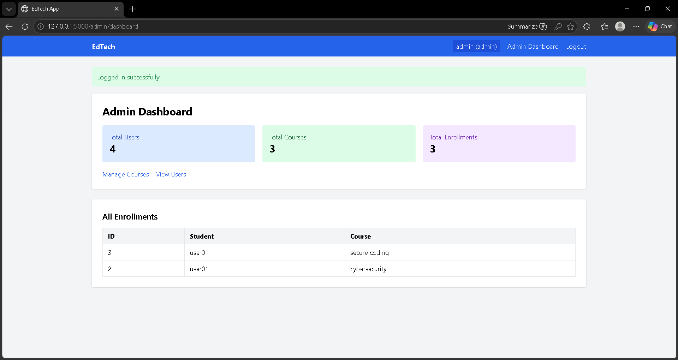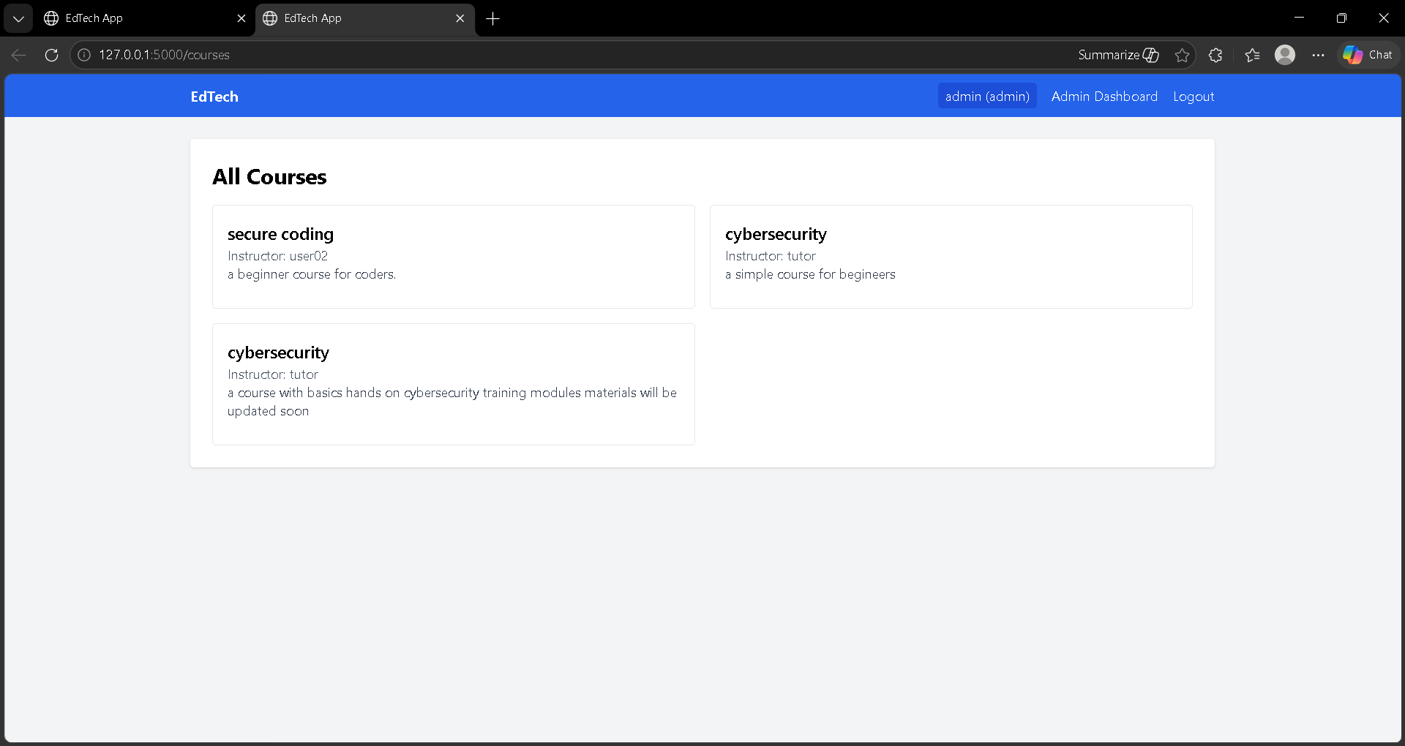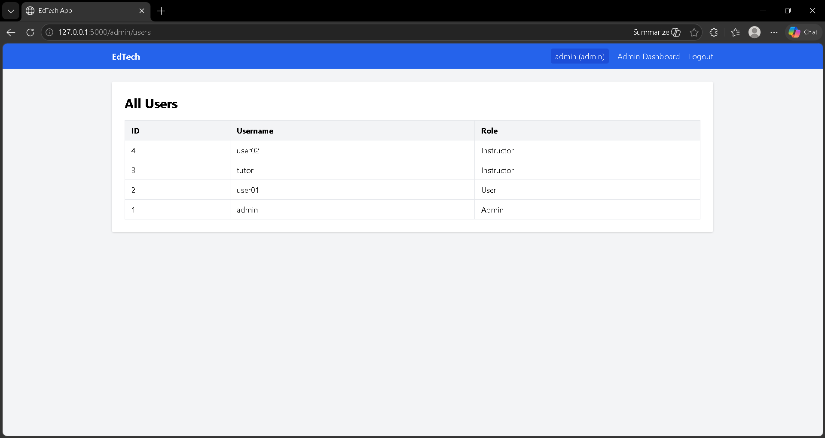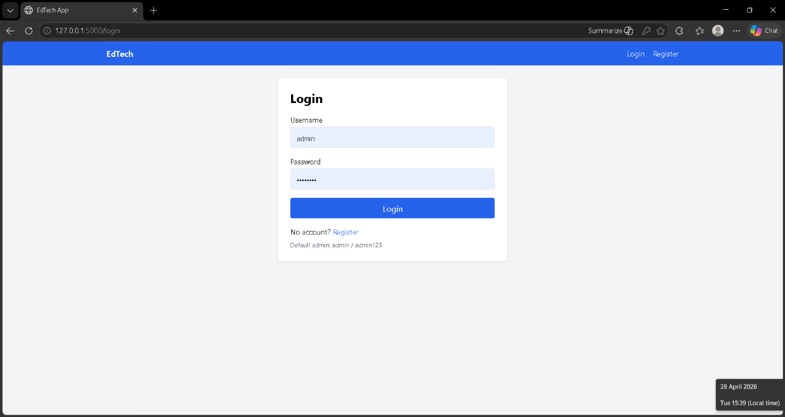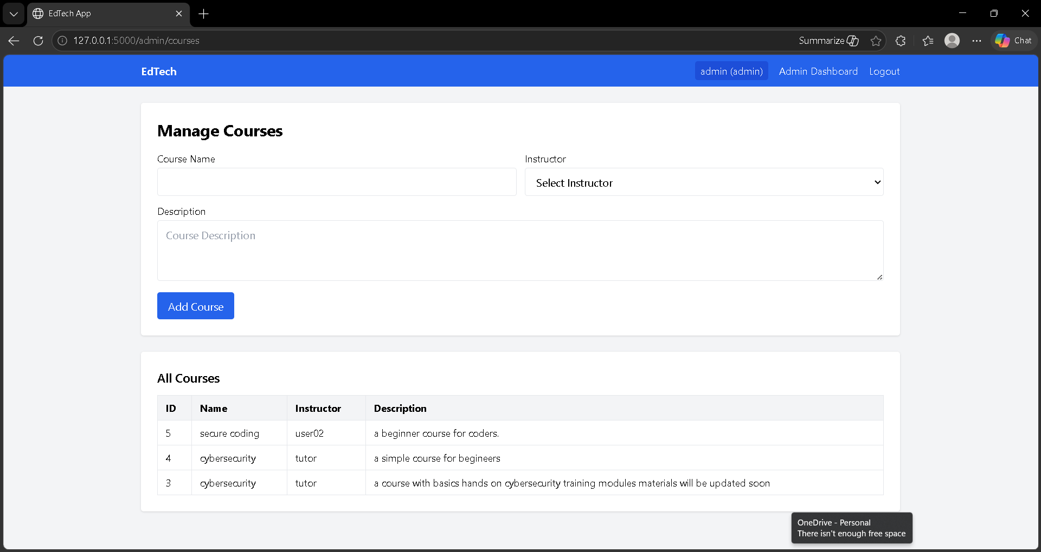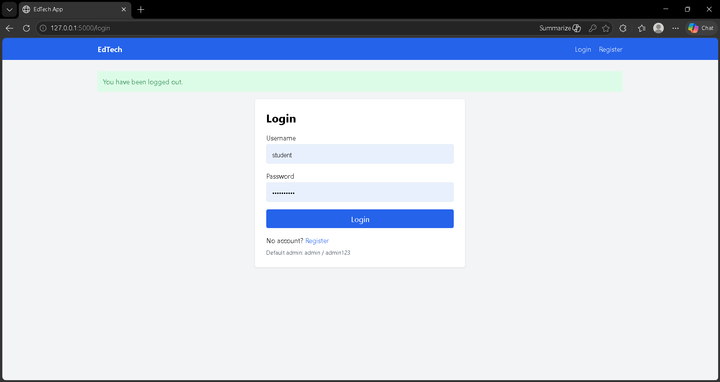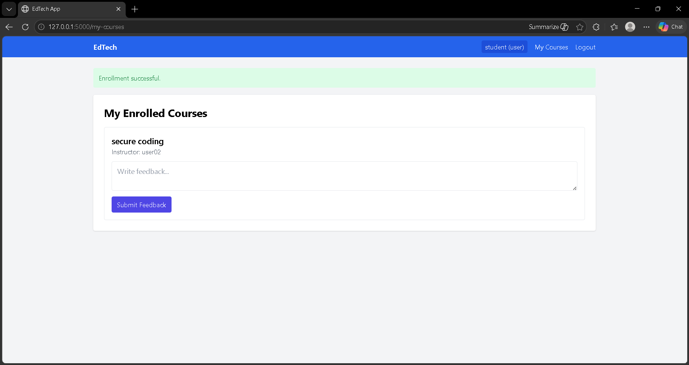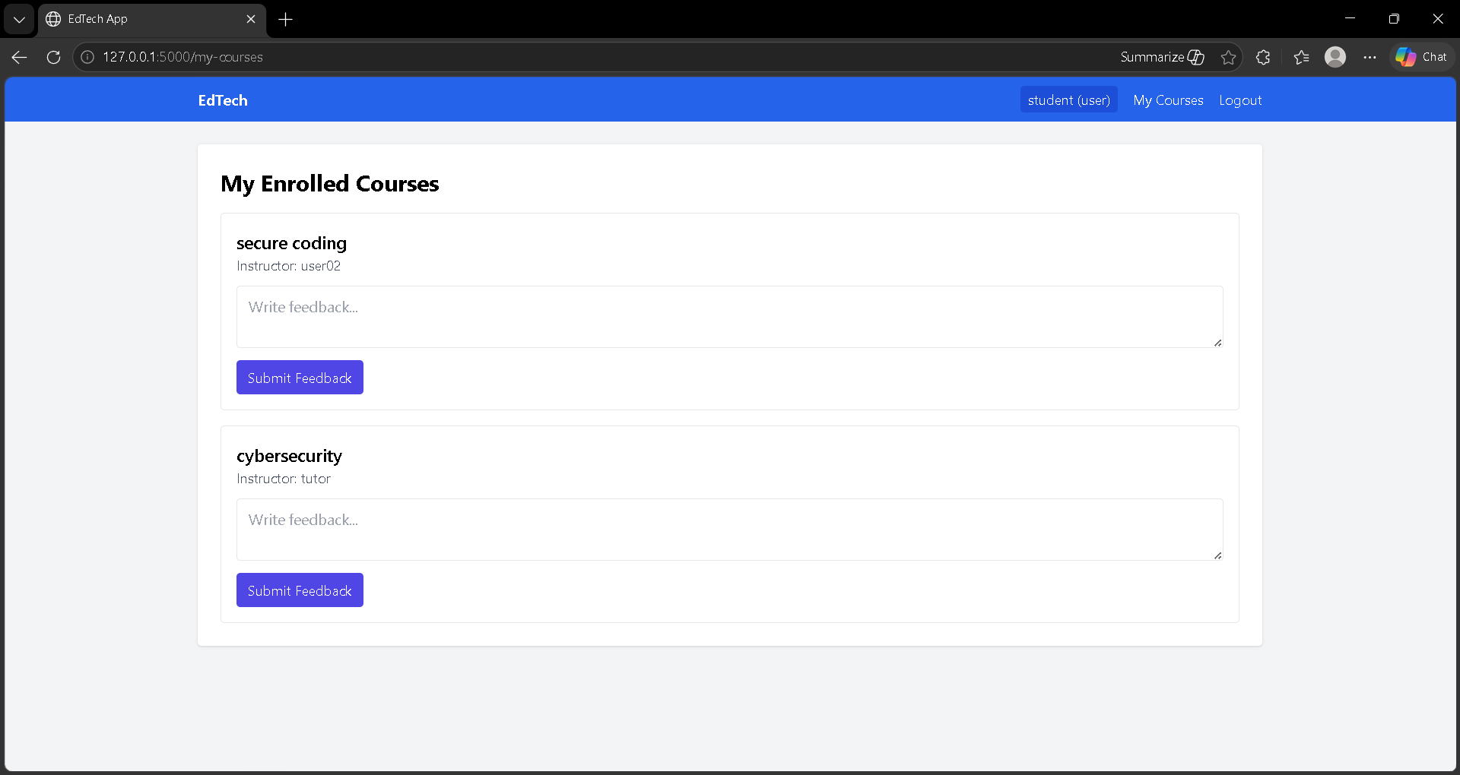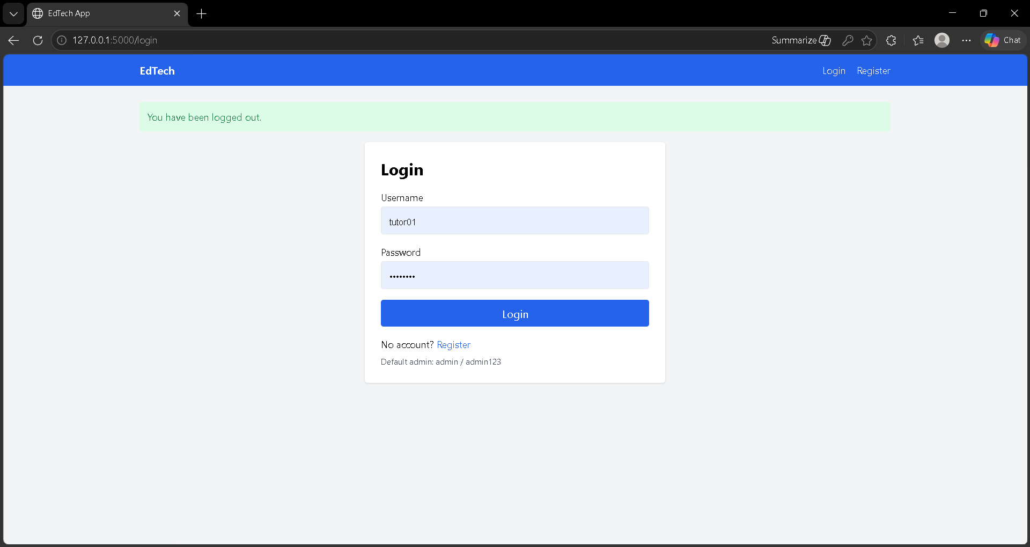

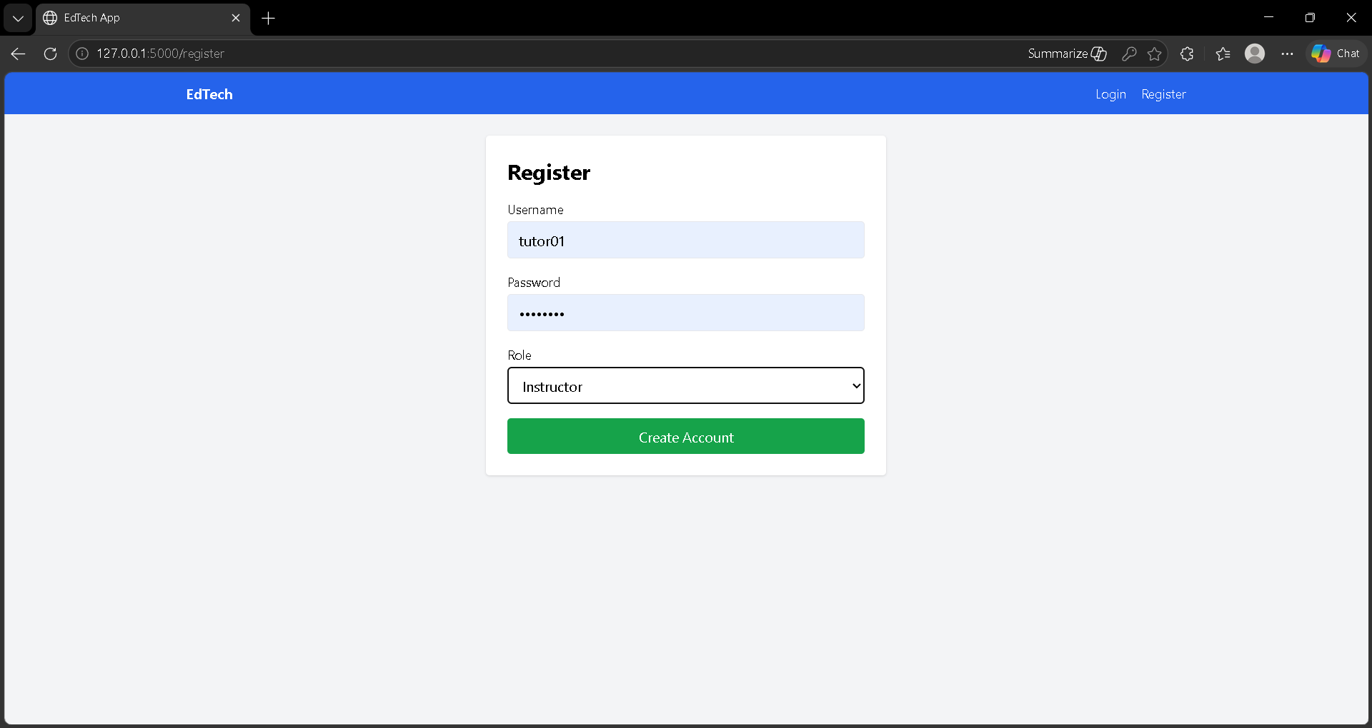

5. Conclusion
The project titled “Identity Security Framework for EdTech System” successfully demonstrates the design and implementation of a secure web-based educational platform. The system focuses on ensuring proper identity management through authentication, authorization, and controlled access to resources.
The application was developed using Flask as the backend framework and SQLite as the database, making it simple, lightweight, and suitable for academic implementation. Security features such as password hashing were implemented using Werkzeug, ensuring that user credentials are stored securely.
One of the key achievements of this project is the successful implementation of Role-Based Access Control (RBAC). The system clearly separates user roles into user (student), instructor, and admin. Each role is assigned specific permissions, ensuring that users can only access functionalities relevant to them. This helps in maintaining system integrity and preventing unauthorized actions.
Another important feature is the course enrollment system, where users can enroll in available courses. The system includes validation mechanisms to prevent duplicate enrollments, ensuring that a user cannot enroll in the same course more than once. This improves data accuracy and avoids redundancy in the database.
The system also implements session-based authentication, which ensures that only logged-in users can access protected pages. Unauthorized access is restricted, and user sessions are properly managed through login and logout mechanisms.
From a usability perspective, the application provides a clean and simple interface using HTML and Tailwind CSS. Users can easily navigate through login, course viewing, enrollment, and dashboard pages. The system is responsive and easy to operate, making it suitable for both beginners and administrators.
Testing results show that:
- Login and authentication work correctly
- Role-based access restrictions are enforced properly
- Course enrollment functions as expected
- Duplicate enrollment prevention is effective

6. Further Development or Research
The current system successfully implements a secure identity framework for an EdTech platform. However, there are several areas where the system can be improved and extended to enhance functionality, security, and usability.
6.1 Progress Tracking System
A future enhancement can include tracking user learning progress. This can allow:
- Students to view completed and pending modules
- Instructors to monitor student performance
- Better engagement and structured learning
6.2 Enhanced Security Mechanisms
Although the system uses password hashing and session management, additional security features can be implemented:
- Two-Factor Authentication (2FA)
- Account lock after multiple failed login attempts
- Secure session timeout handling
These improvements will further strengthen identity protection.
6.3 Improved Role Management
Currently, the system has fixed roles (user, instructor, admin). Future versions can include:
- Dynamic role creation
- Custom permissions for different roles
- Fine-grained access control
6.4 Feedback Analysis System
The existing feedback system stores user input. It can be extended to:
- Analyze feedback trends
- Display ratings for courses
- Help instructors improve course quality

6.5 User Interface Enhancements
The interface can be improved by:
- Adding dashboards with visual summaries
- Improving navigation and layout
- Enhancing responsiveness for mobile devices
6.6 Deployment and Scalability
Currently, the system runs locally using Flask and SQLite. Future improvements can include:
- Deployment on cloud platforms
- Migration to larger databases (if needed)
- Handling multiple concurrent users
6.7 Audit Logging System
A logging mechanism can be added to:
- Track user activities
- Monitor admin actions
- Improve system transparency and security

7. References
- Flask Documentation
https://flask.palletsprojects.com/
- SQLite Documentation
https://www.sqlite.org/docs.html
- Werkzeug Documentation
https://werkzeug.palletsprojects.com/
- Role-Based Access Control (RBAC) Concept
https://csrc.nist.gov/projects/role-based-access-control
- HTML Documentation
https://developer.mozilla.org/en-US/docs/Web/HTML
- Tailwind CSS Documentation
https://tailwindcss.com/docs

8. Appendix
The appendix provides additional technical details related to the system implementation.
8.1 Database Tables
1. Users Table
- id – Unique user ID
- username – User login name
- password – Hashed password
- role – User role (user, instructor, admin)
2. Courses Table
- id – Course ID
- name – Course name
- instructor – Instructor username
3. Enrollments Table
- id – Enrollment ID
- user_id – Reference to user
- course_id – Reference to course
4. Feedback Table
- id – Feedback ID
- user_id – Reference to user
- course_id – Reference to course
- message – Feedback tex
8.2 Key Modules
1. Authentication Module
- Handles user login and registration
- Uses password hashing via Werkzeug
- Maintains session after login

2. Authorization Module
- Implements role-based access control
- Restricts routes based on user role
3. Course Management Module
- Allows instructors and admins to manage courses
- Displays course information to users
4. Enrollment Module
- Handles course enrollment process
- Prevents duplicate enrollments
- Stores enrollment records
5. Feedback Module
- Allows users to submit feedback
- Stores feedback in the database
8.3 System Flow Summary
- User registers and logs in
- Session is created
- User views courses
- User enrolls in a course
- System checks for duplicate enrollment
- Enrollment is stored in database
- Instructor and admin manage system

8.4 Security Features Summary
- Password hashing
- Role-based access control
- Session-based authentication
- Duplicate enrollment prevention

